Practical No 10

VIII. Resources required (Additional)
→ If any web resources required.

Resources used (Additional)
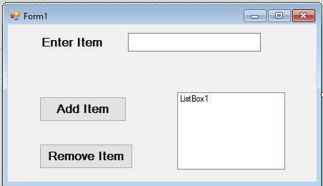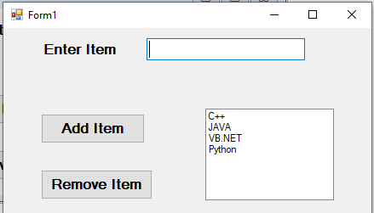→ https://docs.microsoft.com/en- us/dotnet/api/system.windows.forms.listbox?view=netframework-4.7.2
→ https://docs.microsoft.com/en- us/dotnet/api/system.windows.forms.combobox?view=netframework-4.7.2

Program Code
  - Write a program to demonstrate the use of ListBox and ComboBox. (Code for Add Items to ListBox & Remove Selected Item from ListBox)
➢

Public Class Form1
Private Sub Button1_Click(sender As Object, e As EventArgs) Handles Button1.Click ListBox1.Items.Add(TextBox1.Text)
TextBox1.Text = "" TextBox1.Focus()
End Sub

Private Sub Button2_Click(sender As Object, e As EventArgs) Handles Button2.Click ListBox1.Items.Remove(ListBox1.SelectedItem)
End Sub End Class

Results (output of the program):

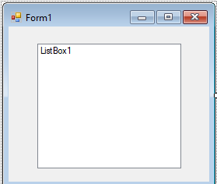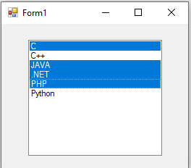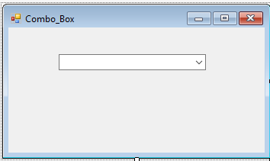
- Practical related Questions
  - Write the program to select multiple subjects using ListBox control.
➢

Public Class Form1
Private Sub Form1_Load(sender As Object, e As EventArgs) Handles MyBase.Load ListBox1.SelectionMode = SelectionMode.MultiSimple ListBox1.Items.Add("C")
ListBox1.Items.Add("C++") ListBox1.Items.Add("JAVA") ListBox1.Items.Add(".NET") ListBox1.Items.Add("PHP") ListBox1.Items.Add("Python")
End Sub End Class

OUTPUT:

  - Write the program to select colleges using single ComboBox.
➢

Public Class Combo_Box
Private Sub Form1_Load(sender As Object, e As EventArgs) Handles MyBase.Load ComboBox1.Items.Add("MET")
ComboBox1.Items.Add("GGSP") ComboBox1.Items.Add("KKW") ComboBox1.Items.Add("GP")
End Sub

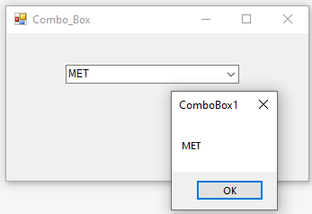Private Sub ComboBox1_SelectedIndexChanged(sender As Object, e As EventArgs) Handles ComboBox1.SelectedIndexChanged
MsgBox(ComboBox1.SelectedItem.ToString) End Sub
End Class

OUTPUT:

- rcise

  - 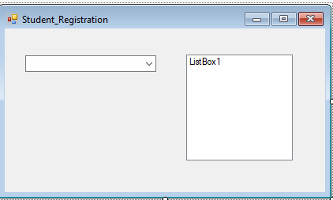Differentiate between ListBox and ComboBox.
- The ComboBox allows to select single items from the Collection of Items. The ListBox allows to select the single of multiple items from the Collection of Items using SelectMode property.

Write a program to select multiple subjects for single semester.
➢

Public Class Student_Registration
Private Sub Student_Registration_Load(sender As Object, e As EventArgs) Handles MyBase.Load
ComboBox1.Items.Add("First Semester") ComboBox1.Items.Add("Second Semester") ComboBox1.Items.Add("Third Semester") ComboBox1.Items.Add("Fourth Semester")
End Sub

Private Sub ComboBox1_SelectedIndexChanged(sender As Object, e As EventArgs) Handles ComboBox1.SelectedIndexChanged
If (ComboBox1.SelectedIndex = 0) Then ListBox1.Items.Clear() ListBox1.Items.Add("Chemistry") ListBox1.Items.Add("Physics") ListBox1.Items.Add("Maths") ListBox1.Items.Add("English")
End If
If (ComboBox1.SelectedIndex = 1) Then ListBox1.Items.Clear() ListBox1.Items.Add("PIC") ListBox1.Items.Add("Maths") ListBox1.Items.Add("CHM") ListBox1.Items.Add("WPD")
End If
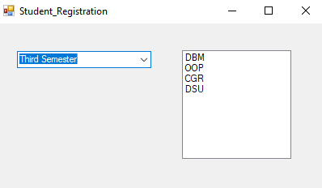If (ComboBox1.SelectedIndex = 2) Then ListBox1.Items.Clear() ListBox1.Items.Add("DBM") ListBox1.Items.Add("OOP") ListBox1.Items.Add("CGR") ListBox1.Items.Add("DSU")
End If
If (ComboBox1.SelectedIndex = 3) Then ListBox1.Items.Clear() ListBox1.Items.Add("JPR") ListBox1.Items.Add("DCC") ListBox1.Items.Add("GUI") ListBox1.Items.Add("SEN")
End If End Sub
End Class

OUTPUT:

